Breast Cancer Awareness Day!

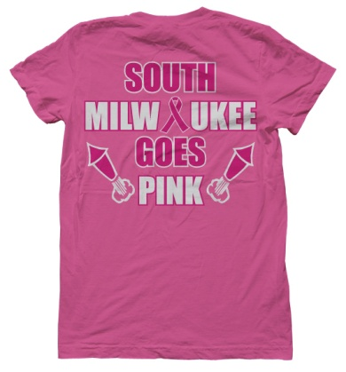


Sponsored by SMHS Adv. Marketing

to the Susan G. Komen foundation by purchasing a t-shirt to wear on October 18th. T-Shirts will be sold for $10 pre-order & $12 after the 5th of October.
Mail this form and checks to:
South Milwaukee High School, c/o David Fix, 801 15th Avenue, South Milwaukee, WI 53172
Shirts will be delivered prior to Oct.18th
Make checks payable to: SMHS by October 5th
Name____________________________ Business/School____________________________________
Address__________________________________________________ Phone ___________________
Size (quantity)
YS___YM___YL___ S___ M___ L___ XL___ Number of shirts times $10_________
XXL____ XXXL_____ Number of shirts times $12 _________
Grand Total _______________

On October 18^{th,} to raise money in the support of breast cancer, the city of South Milwaukee is going PINK! City residents and businesses are encouraged to wear pink to support this worthy cause. You can help raise money to be donated

