SOUTH MILWAUKEE POLICE DEPARTMENT
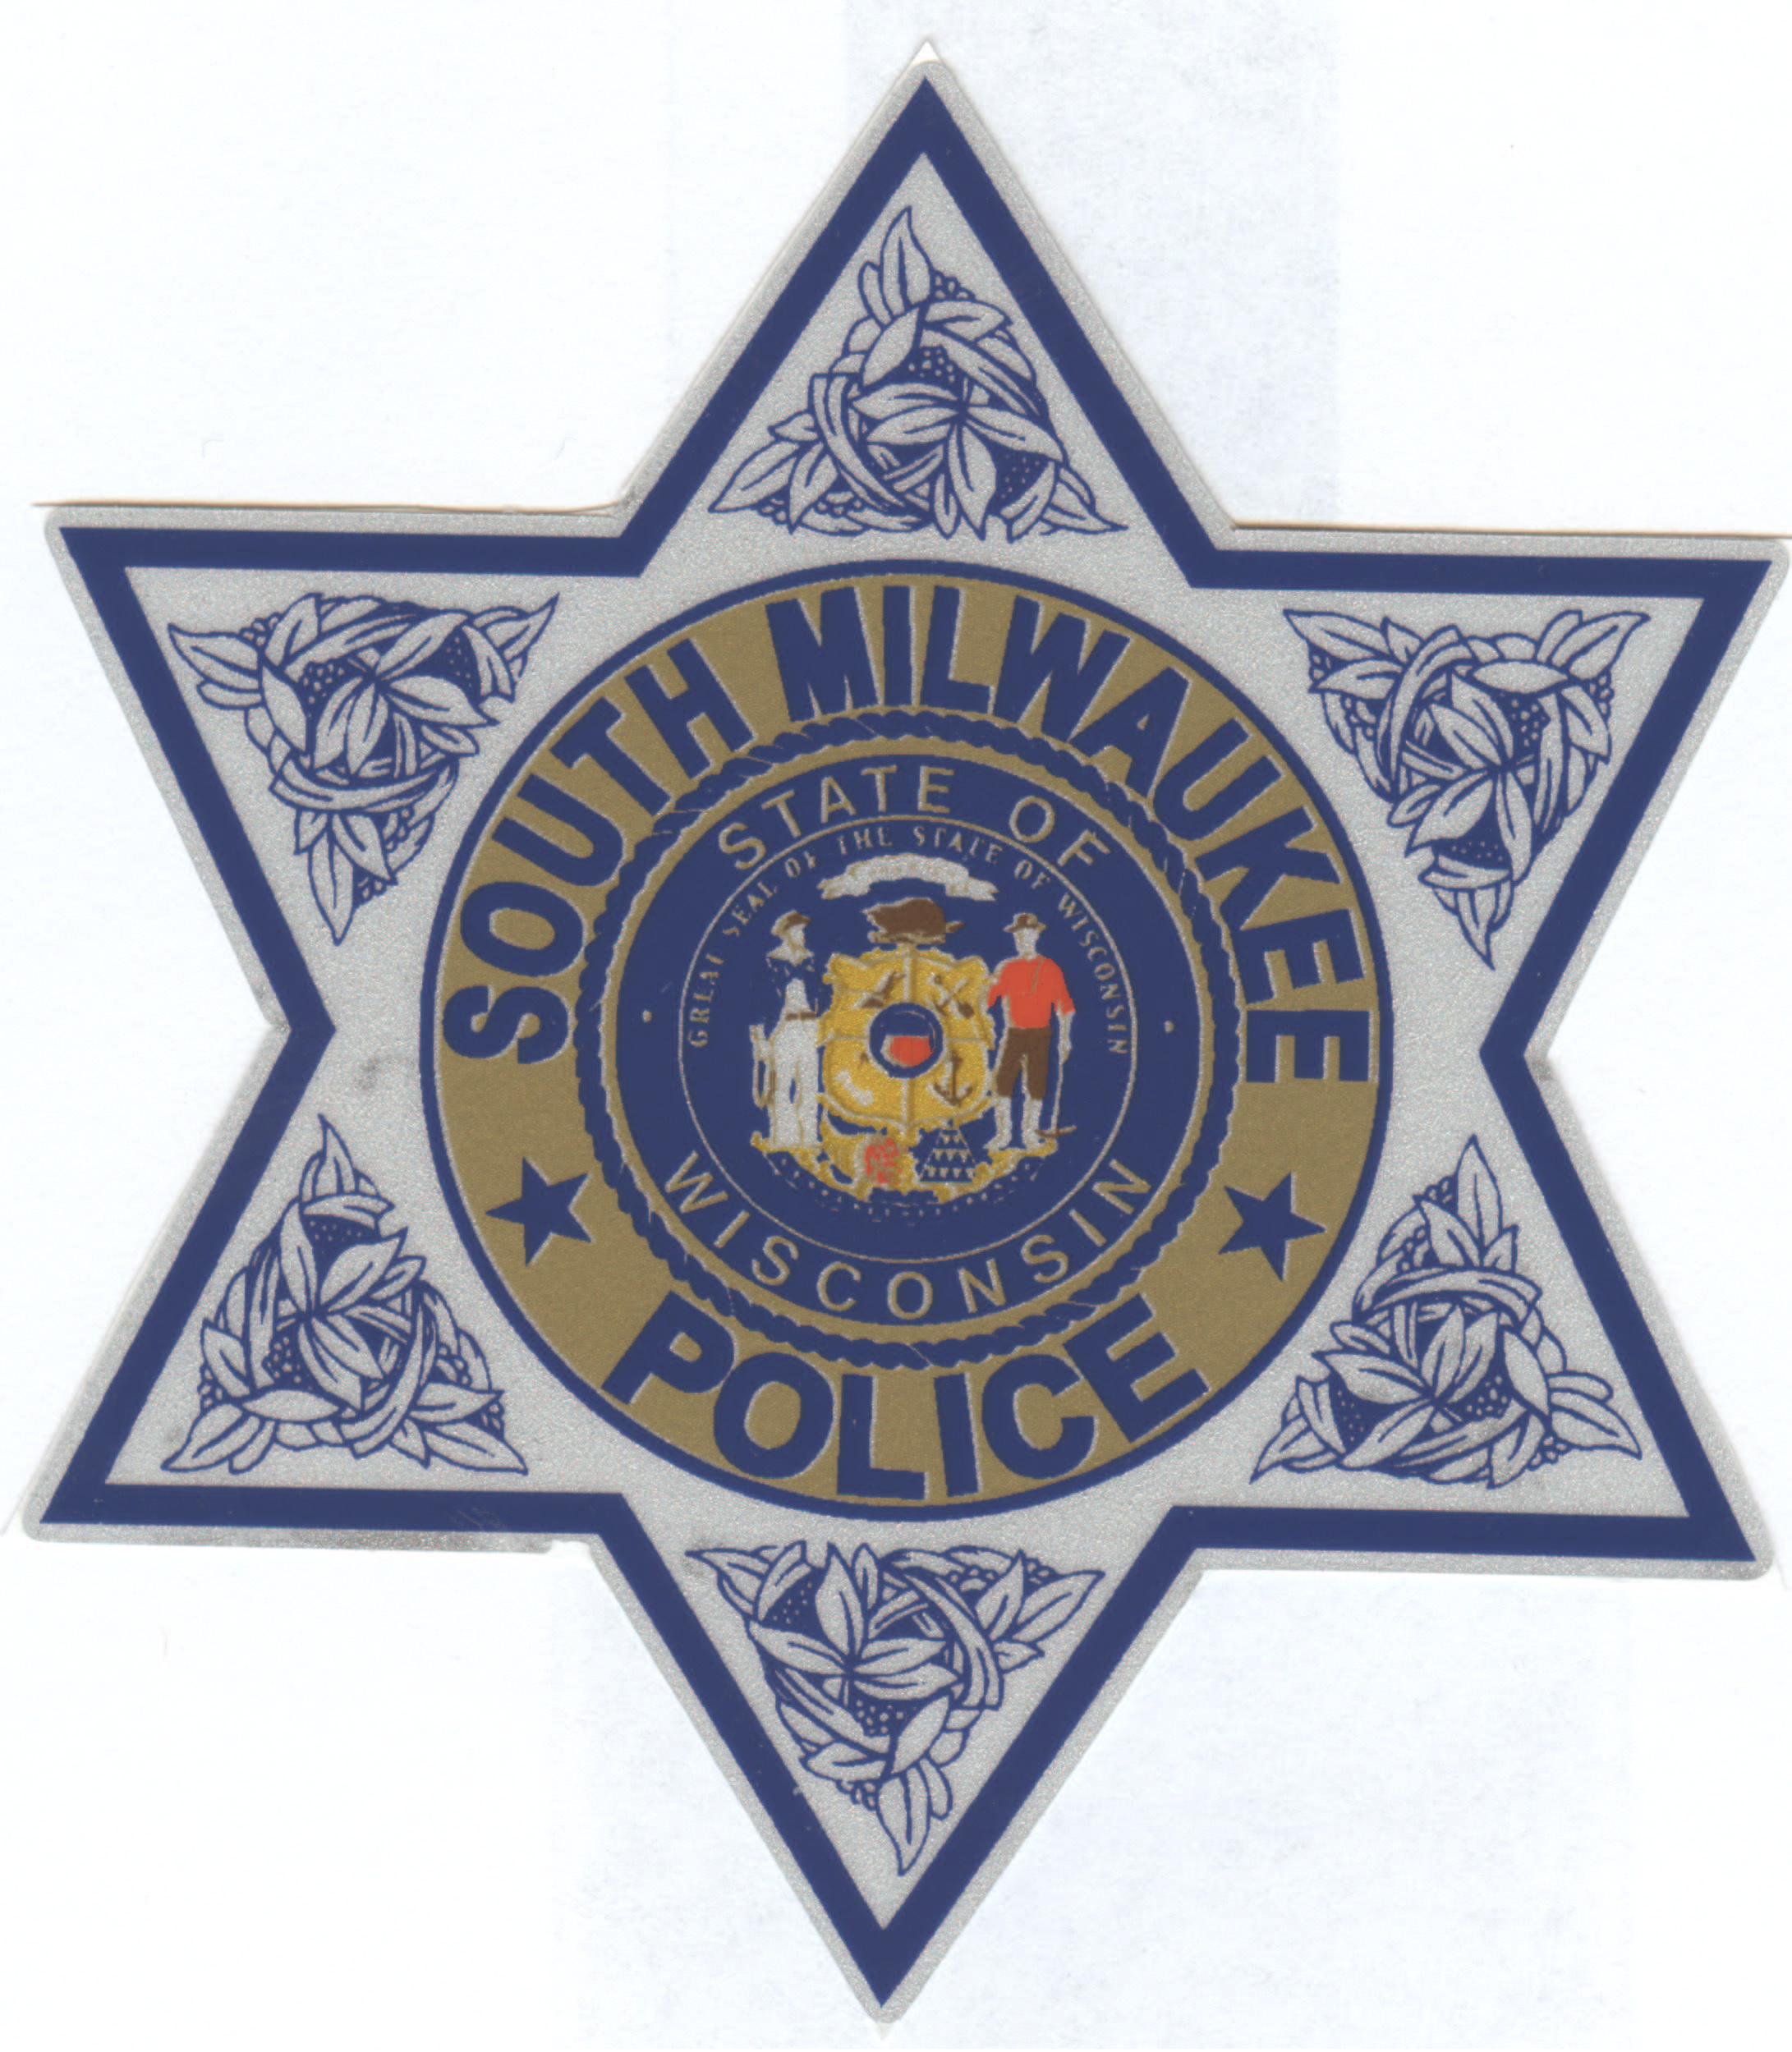

DATE: Sept 26, 2012

TO: Media

FROM: Lt. Milow #731

SUBJECT: Press Release 12-020379

Reference: Car vs Pedestrian accident in South Milwaukee

On September 25, 2012, at 8:01pm, The South Milwaukee Police Department received a call of a car striking a pedestrian in the 1600 block of College Avenue.

The pedestrian, an 18 year old female, was transported by Flight for Life to Froedtert Hospital, where she is being treated. The extent of her injuries is unknown at this time.

This case is still under investigation.
More details will be available in the near future.

Thank you.
Lt Milow

