PROCLAMATION  PROCLAIMING May 17-23, 2015  EMERGENCY MEDICAL SERVICES WEEK  WHEREAS, emergency medical services is a vital public service; and  WHEREAS, the members of emergency medical services teams are ready to provide lifesaving care to those in need 24 hours a day, seven days a week; and  WHEREAS, access to quality emergency care dramatically improves the survival and recovery rate of those who experience sudden illness or injury; and  WHEREAS, the emergency medical services system consists of emergency room staff, emergency medical technicians, paramedics, firefighters, educators, administrators and others; and  WHEREAS, the members of emergency medical services teams engage in thousands of hours of specialized training and continuing education to enhance their lifesaving skills; and  WHEREAS, it is appropriate to recognize the value and the accomplishments of emergency medical services providers by designating Emergency Medical Services Week;  NOW THEREFORE, I, Erik Brooks, Mayor of the City of South Milwaukee, call upon all citizens of South Milwaukee and upon all patriotic, civic and educational organizations to observe the week of May 17-23, 2015,  EMERGENCY MEDICAL SERVICES WEEK  In witness thereof, I have hereunto set my hand and caused the Seal of South Milwaukee to be affixed. Signed at the City of South Milwaukee this 19th day of May, 2015.  Erik Brooks, Mayor  City of South Milwaukee
  
  National Emergency Medical Services Week
  May 17-23, 2015
  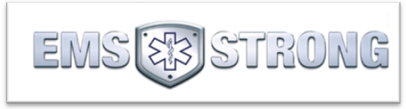

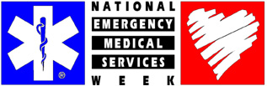
Letter of Commendation
Capt. Brad Sibley FF/P Steve Bartlein
FF/EMT Ryan Behling FF/P Jeremy Fronczak
FF/EMT Tyler Anders FF/P Andy Mahn
FF/P John Rhinesmith

The morning of Monday, February 2nd, 2015, started out as most winter days do at the South Milwaukee Fire Department with snow removal on the “to-do” list for the on-duty crew as approximately 12” of snow fell in the area in the past 24-36 hours.
Then, at approximately 10:24AM that morning, SMFD responded to a 9-1-1 call from a male caller stating that he was experiencing chest pain and trouble breathing, most probably from being outside shoveling just prior to calling. Upon the arrival of SMFD units, the caller was found walking around his house letting his dogs out so the fire department members could tend to him. Upon evaluating the patient, an EKG showed that he was experiencing a myocardial infarction or heart attack. An IV was started and treatment of aspirin and Nitroglycerin was immediately begun. While preparing the patient for transport to the hospital and moving him to the ambulance, the patient became unresponsive and went into cardiac arrest.
Personnel immediately started their treatment protocol for cardiac arrest by initiating CPR, assisting his respiratory efforts and administering medications. The patient soon regained his pulse and became responsive, only to go unresponsive again shortly thereafter. CPR was resumed and, once again, the patient regained consciousness and became responsive.
The patient, a 60 y/o male, would become the only survivor of three pulseless, non-breathing patients SMFD would respond to that morning.

Letter of Commendation
FF/P Brian Bieganski
FF/P Ryan Wendt

At approximately 9:06AM on Thursday, February 19th, 2015, the City of Cudahy requested a paramedic unit to respond to their Middle School for a report of a student who was experiencing difficulty breathing in the pool area. It wasn’t until the paramedics from South Milwaukee’s Med-10 arrived on scene that they were informed that their patient was pulled unresponsive from the pool by a teacher who immediately started CPR.
The Cudahy Fire Department, who arrived on scene first, continued the life-saving efforts started by the teacher until the arrival of Med-10, who then took over resuscitation efforts and initiated advanced life support for an unresponsive drowning victim. While en route to Children’s Hospital, the patient regained her pulse and started to wake up.
Without the teamwork of all involved - the teacher, the Cudahy Fire Department personnel and, especially, the Paramedics from South Milwaukee’s Med-10, the outcome would predictably not been so favorable.

