SOUTH MILWAUKEE POLICE DEPARTMENT
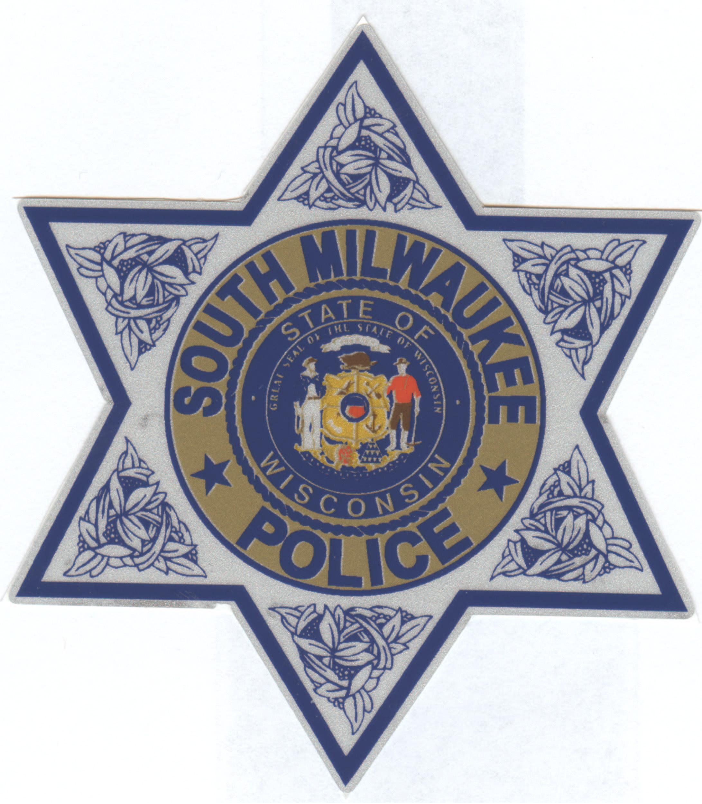

DATE: May 8, 2017

TO: Police & Fire Commission

CC: Mayor Brooks
Clerk Shelenske

FROM: Chief Ann Wellens

SUBJECT: Police Awards
Common Council Meeting
May 16, 2017

The week of May 14 – 20, 2017 has been designated as National Peace Officers Week. In conjunction with National Peace Officers Week the Police Department will be holding our Annual Department Awards to recognize selected staff and citizens from the community.

On Tuesday, May 16, 2017 nine officers, eight citizens and one business will be presented Police Department Awards at the Common Council meeting. Mayor Brooks has kindly allowed time at the beginning of the meeting for the Department presentation. The following officers, citizens and business will be receiving the following awards:

MERIT AWARD: awarded for excellent arrest by any officer directly involved in the capture and arrest of a felon who was endangering the lives and/or property of the Community.
AND

CITIZEN RECOGNITION AWARD: awarded to any citizen when any officer believes that the behavior/actions of a citizen is deserving of recognition by the Department.

Lt. Rotter, Investigator Olson, Investigator Rivamonte, Officer Fournier, Officer Schwehr and Mr. Brian Tommet - nominated by Captain Jaske & Lt. Rotter

On February 22, 2017 in the early morning hours Mr. Tommet observed what he believed to be suspicious activity at the You Pump Gas Station located at 1715 10th Avenue. Mr. Tommet observed two males walking around the closed gas station and alerted the South Milwaukee Police Department. Unknown to Mr. Tommet these two subjects had just burglarized the business. Because of Mr. Tommet’s swift action in calling the Police Department immediately officers responded to the scene quickly and after an in-depth investigation were able to identify one suspect. This suspect’s arrest and subsequent confession assisted in the closure of several gas station and pharmacy burglaries throughout the Milwaukee and Waukesha County area.

Without Mr. Tommet and the solid work of Officers Fournier and Schwehr, Lt. Rotter & Investigators Olson and Rivamonte in this case, the department would not have had anything other than another burglary with little to no leads. The result of their team work concluded with a dangerous felon being removed from the streets.

MERIT AWARD:

Investigator Olson and Officer Stratton – nominated by Captain Jaske

January of 2016 Officer Stratton received a complaint of a sexual assault of a 25 year old female who was severely autistic with minimal communication skills. The suspect was a transit driver who took the woman to and from locations. Investigator Olson assisted Officer Stratton with the investigation. This was a very detailed investigation which involved several search warrants for evidence and an intense interrogation of the suspect. Through the officers investigation the suspect was charged by the Milwaukee County District Attorney’s Office with 2nd Degree Sexual Assault. It is unknown how many other helpless individuals this suspect may have violated prior to this incident. Through Investigator Olson and Officer Stratton’s hard work and perseverance a dangerous sexual predator was taken off the streets.

SUPERVISOR RECOGNITION AWARD: given for outstanding police work.

Officer Steven Streicher – award from Captain Pete Jaske incident #16-16852

Investigator Carol Olson – award from Captain Jill Kallay incident #17-XXXXXX
Officer Craig Hauski, CUPD – MERIT AWARD – Chief Wellens

Cudahy Police Officer Hauski is being awarded a Merit Award for his actions regarding the March 10, 2017 robbery of the South Milwaukee Tri-City National Bank. Officer Hauski was monitoring the radio communications on March 10, 2017 when a robbery was reported at the South Milwaukee Tri-City National Bank. Officer Hauski positioned himself at a possible escape route for the suspect vehicle. Officer Hauski did locate the suspect vehicle traveling through the City of Cudahy and attempted to stop the vehicle. The suspect vehicle eluded the stop and a pursuit ensued. Upon termination of the pursuit Officer Hauski pursued the suspect who fled the scene on foot. Officer Hauski was able to apprehend the robbery suspect. The quick thinking of Officer Hauski helped to bring this robbery suspect into custody. Without his assistance this dangerous subject would have continued his crime spree; he had already committed another robbery in the Village of Shorewood that morning.

LETTER OF COMMENDATION: given for outstanding police work.

Investigator Craig Perkowski – Chief Wellens

Investigator Perkowski received a Unit Service Award from the Milwaukee Police Department on November 2, 2106 for his involvement with a large scale drug investigation in the City of Milwaukee. Through this investigation several large scale drug dealers were arrested and taken off the street.

CITIZEN RECOGNITION AWARDS:

Mr. Christopher Rodriguez – nominated by Officer David Hoeppner

On June 13, 2016 at approximately 3:03 am Mr. Rodriguez observed a residence on fire in the 2400 block of Nicholson Avenue. Mr. Rodriguez immediately went to the residence and began pounding on the doors to awaken the residents. Through Mr. Rodriguez’s actions all the occupants of the residence were able to safely evacuate the residence. Mr. Rodriguez then called 911 to alert emergency personnel and then began trying to extinguish the fire by using a garden hose to apply water. Both the Police & Fire Departments responded to the residence and took over fire suppression efforts. Because of Mr. Rodriguez’s quick actions all six occupants of the residence were saved.

Mrs. Tami Mayzik & Mrs. Kari Strasser – nominated by Officer Nathan Siefert

On October 30, 2016 Mrs. Mayzik & Mrs. Strasser were walking in Grant Park when they observed a group of youths breaking into a vehicle and removing property from the vehicle. The women had the presence of mind to take a photograph of the suspects leaving the scene and turned over this evidence to the Police Department. Through their quick thinking to obtain photographic evidence the Police Department was able to identify and apprehend a group of teens who had been involved in several crimes throughout the area. The apprehension of these youths recovered a stolen vehicle from the City of Greenfield, and the recovery of a substantial amount of stolen property from Milwaukee and South Milwaukee. Without Mrs. Mayzik’s and Mrs. Strasser’s assistance these suspects would not have been identified and would have continued to commit other crimes in the greater Milwaukee area.

Mr. Devlin Mcelwee & Mr. Oscar Knapp – nominated by Officer Daniel Fournier

On November 19, 2016 in the early morning hours Mr. Mcelwee & Mr. Knapp were traveling on Lake Drive in South Milwaukee when they observed a vehicle crash into a tree. The gentlemen immediately stopped their vehicle and went to assist the driver of the crashed vehicle. While they were attempting to free the driver from the vehicle it started on fire. By the time the two men freed the driver and moved him to a safe location the engine compartment of the vehicle was fully engulfed in flames. The officers who arrived on scene stated their actions saved the driver’s life.

Mr. Dustin Bierbach – nominated by Investigator Jonathan Rivamonte

On January 23, 2017 Mr. Bierbach was the “Keynote” speaker at the South Milwaukee Addiction Information Resource Fair. Mr. Bierbach spoke from his heart about his personal struggles with drug addiction and made a great impact on those that attended the fair. Investigator Rivamonte stated the following “Dustin was extremely brave to come and talk about his addiction … he is a role model for other recovering South Milwaukee addicts.” The Committee which organized the fair also received many positive comments regarding Dustin’s speech. Dustin should be commended on his commitment to help other citizens understand this addiction.

Mr. Jacob Klingforth – nominated by Officer Steve Streicher

On March 13, 2017 as Mr. Klingforth was traveling in South Milwaukee he observed a subject laying on a sidewalk who appeared to be in need of help. Mr. Klingforth immediately took action and went to assist this subject. The subject was pulseless and not breathing. Mr. Klingforth activated 911 emergency services and began CPR until assistance arrived. Even after medical personnel arrived on the scene and assumed patient care Mr. Klingforth remained at the scene and assisted the officers who responded. Mr. Klingforth’s care and compassion for this subject is commendable.

Mr. Tony Girard – Owner Tony G’s Grant Park Garage

Mr. Girard is receiving a Citizen’s Recognition Award for his continued support of our community. Mr. Girard has provided support to the Police Department in the following police programs: the DARE Golf Outing, Community Night Out and Shop with a Cop program for the past several years. Mr. Girard is always willing to assist the Police Department whenever he can. Mr. Girard is a true community partner.

